Self and Peer assessment form for COM109 Coursework 2

Please assess your contribution to the preparation of the solution to the COM109 coursework in relation to that of your other team member.

Did each of you contribute equally? If so, each team member will be given an equitable apportioning of the marks. For non-equitable efforts, those contributing less than their fair share will receive a scaled mark accordingly.

Allocate a mark for each member of your team. Ensure that the marks together total 100.

Group ID (eg: subGroupA):

Peer Contribution Evaluation

Group Member Name | Student ID | Estimated Contribution (%)
 |  | 25%
 |  | 25%
 |  | 25%
 |  | 25%
Total |  | 100%

What particular responsibility/tasks did each team member undertake during the preparation of the assignment solution?
completed: (1) Gallery and Reviews page; (2) responsive CSS; (3) reservation validation; (4) Cookie Consent Banner; (5) navigation fixes; and (6) GitHub maintenance.
completed: (1) reservation page; (2) responsive design; (3) booking JavaScript and localStorage; (4) confirmation and receipt features; (5) link fixes; and (6) testing and GitHub maintenance.
completed: (1) Menu page; (2) responsive styling and filtering; (3) Admin Dashboard; (4) booking search and statistics; (5) CSV export; and (6) testing and GitHub maintenance.
completed: (1) Staff Portal Login; (2) shared style.css; (3) responsive CSS; (4) reusable utils.js; (5) resource and navigation fixes; and (6) testing and documentation, GitHub control.

Self-Assessment Checklist
Task | Yes / No
- Created HTML structure and web pages | Yes
- Styled the site using CSS (including responsiveness) | Yes
- Developed JavaScript functionality (animations, validation) | Yes
- Worked on form validation and user input handling | Yes
- Integrated accessibility features | Yes
- Managed version control (GitHub) | Yes
- Documented code and wrote report sections | Yes
- Debugged issues and tested functionalities | Yes
- Organised group meetings & coordinated tasks | Yes
- Packaged and submitted final assignment files | Yes

Repository Link: https://github.com/Satirtha7/Book-IT

1. Introduction
The group produced The Golden Leaf, a contemporary multy-page restaurant website which contains the information on the restaurant menu photo gallery, reviews, and reservation for a table. Their coursework takes the group website to be an example of semantic HTML code, layout with Flexbox/Grid CSS, transitions or animations, JavaScript/jQuery, dynamic event handling, form validation, and client-side functionality.
I was responsible for creating the staff login page in login.html, working on the development of shared style.css and maintaining it, making changes to responsive.css to fit multiple device sizes, and I was in charge of creating utils.js with JavaScript functions that can be reused in different parts of the site. I combined different CSS and jQuery references into pages, fixed links to navigation and resources. I also kept the project pages updated and shared all that in public. It was my way of working with the team in GitHub where through regular check-ins of my code, merging it with the main branch, etc. we managed to track versions of our work, know what had changed, and that way we can all collaborate more or less efficiently.
Before starting to code, I decided to create a shared design system that would make "The Golden Leaf" look the same on every page no matter who made the different pages. I thought of planning CSS variables (colours fonts shadows, transitions) first in a :root block that was reusable and wouldn't require other pages to have the same styles to be repeated again and again. For responsive.css, my plan was to have four predefined breakpoints (1200px 992px 768px, 480px), figuring out how navigation, grids, and forms will behave at each level of the screen size. I further thought of writing utils.js with commonly shared functions (booking IDs, date/time formatting) to get away from repetitive logic. As for the login page, I prepared the interface of a mock-authentication with visible loading feedback.

2. Describe the Staff Login Page – login.html
I was the one who created a Staff Portal Login page mainly to facilitate and guide staff to the administrative dashboard. I employed HTML5 for the layout, UTF-8 for encoding and also made the page responsive with viewport. That way the page will not only be correctly displayed but also functionally compatible across devices. Besides, it is linked with the common style.css and responsive.css so that all elements look and feel in tune with the rest of the website.
The login form features two fields: Username/Email and Password with labels plus required attribute in place. Having such labels really helps the reader and enhances the user-friendliness as well. required attribute, then again, does not perform any elaborate validation but at least, it will keep the user from being able to submit empty fields.
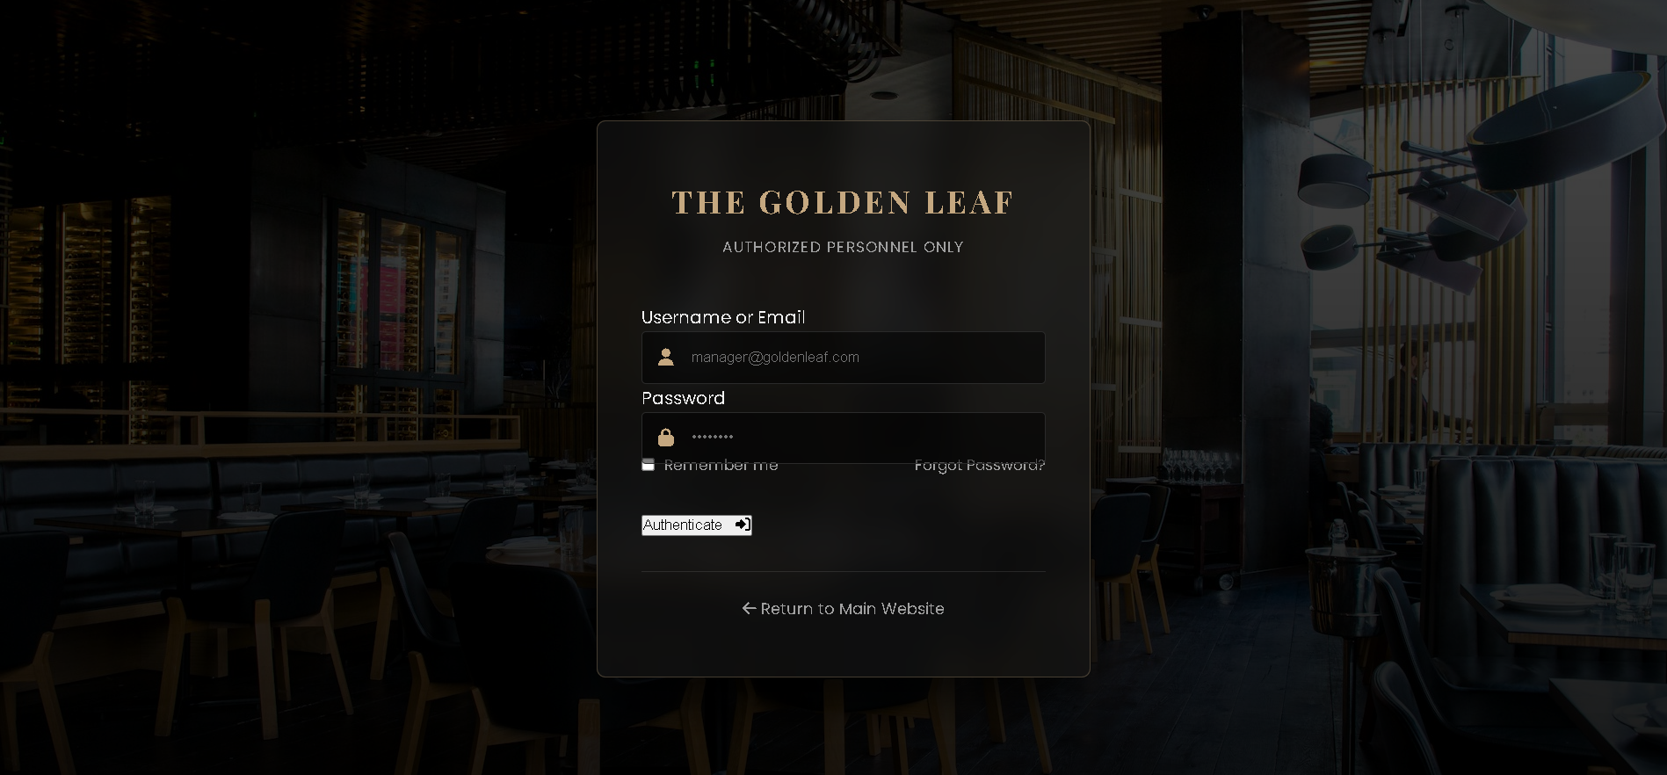
Figure 1: Staff Portal Login Page-Desktop View
For my interaction, I used the DOMContentLoaded event to make sure that JavaScript will have a valid access only to the loaded HTML elements. A submit event was attached to the form. The default behaviour of the browser was prevented with preventDefault() so that my JavaScript could take over and manage the process.
After submission, the button changes from "Authenticate" to "Verifying..." together witha loading icon. This is to immediately show and the user is not left guessing that the button had been pressed but nothing happened.
The window.location.href is used after window.location.href is redirected to admin.html after a setTimeout() has been used to simulate a delay of 1.5 seconds of authentication. If there hadn't been these features the form would have less validation and user feedback and the administrator page would not have been displayed the user automatically.
This scenario is a mock one on the client-side which is not a real authentication system. This code does not even check the validity of the credentials with the server or database. This shortcoming must be pointed out clearly in the report.
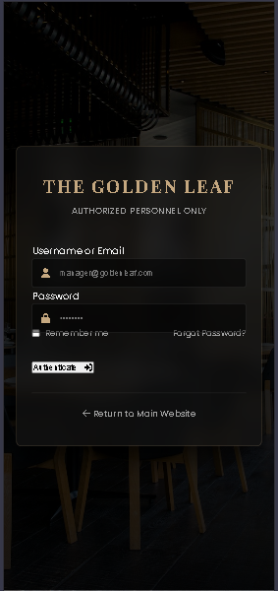
Figure 2: Staff Portal Login page – Mobile/responsive view.

3. Describe the Shared style.css – Consistent Visual Design
I developed the shared style.css to provide a consistent visual design and reusable styling system across the website. I first created CSS variables in :root for the main gold colour, dark backgrounds, text colours, fonts, transitions and shadows. This allows the same design values to be reused throughout the stylesheet and makes future changes easier.
I also applied a global reset using box-sizing: border-box, removed default margins and padding, and made images responsive with max-width: 100% and height: auto. This helps prevent inconsistent browser defaults and layout problems.
In the navigation, I used the Flexbox to position the logo and links and the position: sticky keeps the navigation apart when the scroll down through the page. And the hover and active state of the navigation change the linkcolour to the primary gold. Designed reusable primary and secondary button that has transition and hover effect.
Primary button has hover effect for hover to transparent background for gold background. Secondary button has hover effect for hover to light background. For the homepage I went with a fullscreen hero section with a dark overlay, image and flexible positioning.
I built a CSS Grid for feature cards that auto-fit and minmax(), so that they are flexible given the available screen width. They also make use of transform, border colour and box-shadow for the feature cards on hover. This adds more interaction and helps give the user feedback.
By creating reusable variables, utilising Flexbox and Grid and having a unified class structure keeps the website clone consistent in whole.
Had this shared CSS not been introduced: pages may have had differing colors, spacing and typefaces, layouts may have been more difficult to maintain and less adaptable.
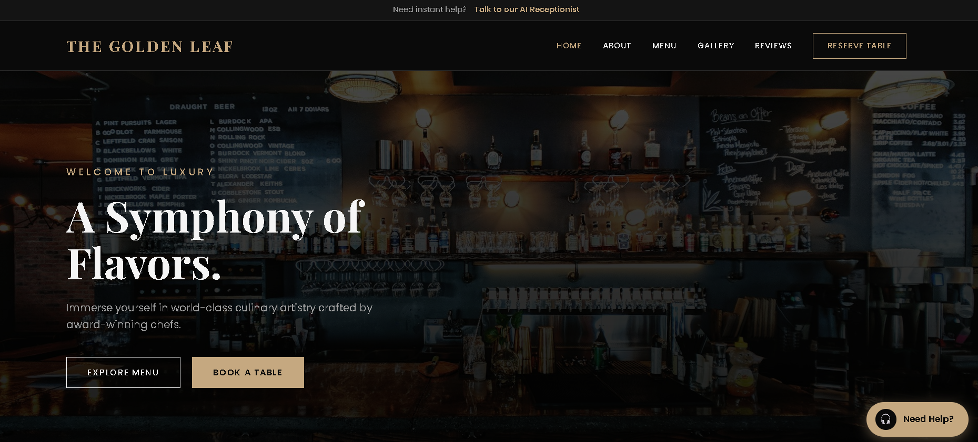
Figure 3: Home page demonstrating shared style.css implementation, including the navigation, hero section, buttons and feature-card grid.
4. Responsive Design – responsive.css
Instead of creating designs only for desktop, I created responsive.css so that the web pages automatically adjust to different screen sizes. I used four screen size ranges: 1200px 992px 768px and 480px, each changing something in the web page when the physical viewing area gets narrower.
When the screen became narrow at 992px. I went for the vertical layout and changed the flex-direction of the chef and booking sections to column, respectively. this change helps make the layout more suitable for tablets. For the same reason, I took away the grid from the gallery layout which prevented large pictures from being spread out to multiple columns when displayed. At 768px, I made a few changes to the navigation links. The normal navigation links were hidden with display, none and display:block. The. menu-toggle. The grid layout in the menu and the rows for the forms became one column. When the navigation has the active-class, I display links vertically.
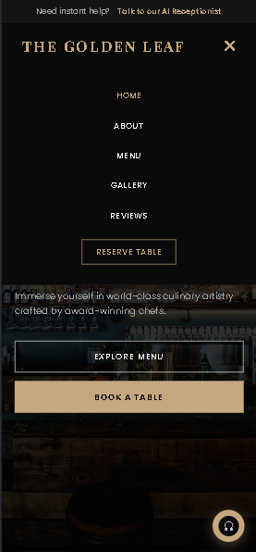
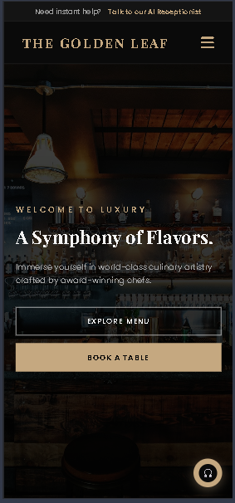
With 480px, I have a width nav in the overflow-x: hidden mode, I have small text and make main and second buttons to be 100% width, stacks up one set of 2. Menu filtering layout in one column. These changes help a person to be able to read and use the contents of a document on a tablet and mobiles screen after having done responsive. Had responsive. The problem would have been that if responsive. css was not used then the website's multi-column layout, navigation, and forms would have been squeezed and overflowed on small viewports. Users might find themselves zooming and scrolling horizontally to see them.
Figure 4: Mobile view demonstrating responsive design implementation.
5. Reusable JavaScript – utils.js
One of the things I did was create a utils.js file so that the JavaScript functions that are used repeatedly will now just be in one reusable_Utils object. It's really great to have the code as concise as possible and to reduce code duplication to the minimum.
A generateBookingID is a function that returns a booking ID which starts with RES- followed by four digits that are randomly generated. So offers a really simple and user-friendly way of identifying the booking.
With the aid of toLocaleDateString(), the formatDate() converts the date string to such displayable format as Oct 24, 2026. Compared to machine-friendly date strings, it will be much easier and less technical for a person to read.
Using the split method we are able to separate the 24-hour time string into hours and minutes, then decide if it is AM or PM, convert the hour to 12-hour format, and finally, get a time string that is human understandable and very easy to read.
As a result, we will have a much cleaner code base and better user experience on this particular feature. So, it is very obvious that the project will be plagued by duplicated logic if, instead of putting all the functions needed in the different html/js files, we keep duplicating them everywhere. That means, by having all of these functions in the utils.js is very helpful in that if there is any change or upgrade of a function the change is only to be made at this single location only. Such centralized sharing and maintaining of functionality is one of the main advantages.
6. Testing and Validation
I tested my contribution across desktop, tablet and mobile screen sizes to check that the login page, shared styling and responsive layouts worked correctly. I checked the login form's required fields, submission behaviour, loading message and redirection to the admin page. I also tested the responsive navigation, stacked buttons, grids and forms at smaller screen widths.
The testing showed that the main features worked as intended, with the responsive CSS preventing layout overflow and maintaining usability on smaller devices. I also reviewed the GitHub changes and corrected resource links and unused CSS during development.
Overall, my contribution successfully improved the website's functionality, consistency, responsiveness and maintainability.
7. Conclusion
Total, I believe my main achievement related to The Golden Leaf Restaurant website was not only the development of the key technical elements I mentioned above, like the Staff Portal Login, shared styling, responsive design and JavaScript utilities, but also how those were successfully integrated to maintain an overall coherent and quality product of the group project.
For a small-scale implementation of the Staff Portal Login, besides the basic HTML and JavaScript I had also included the client-side validation, loading messages, client-side access to the admin page. Despite Really this is a client-side implementation rather than secure server-side authentication, it was a great enough solution that met the project requirements.
By doing so not only I created shared style.css that used CSS variables, reusable classes Flexbox Grid, transitions, and hover effects I also maintained an aesthetically consistent look that would be pleasing to the eyes throughout the site. Also I prepared-responsive.css file with breakpoints for laptop, tablet and mobile devices So making sure that layouts forms buttons, navigation, and content could be used comfortably even without horizontal scrolling.
In addition, util.js provided several JavaScript functions that can be reused, e.g. generating booking IDs and date/time formatting, this way illustrating the concept of code reuse as well as separating of concerns.

